Switch Firmware Upgrade Procedures

Step 1 Setting up a Network Environment
Power on the switch and connect the PC to the management (MGMT) port on the switch with an Ethernet cable.
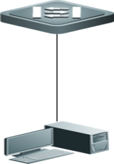

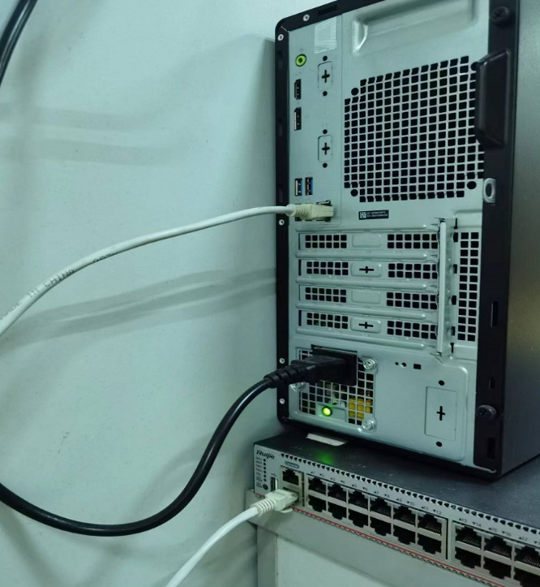
e.g.

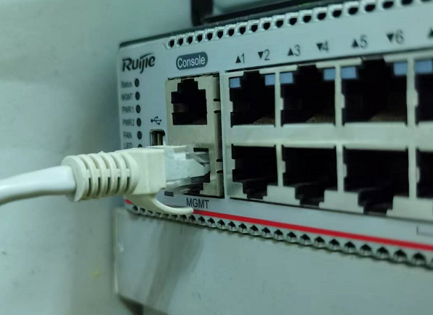

Step 2 Logging in to the Web Management System

Requirements for the client:
- You can manage the switch by logging in to the Web management system of the switch through the browser of the client. The client can be a PC or other mobile devices, such as a laptop.
- Browsers: Internet Explorer 9 to 11, Google Chrome and 360 Browser are recommended. If you log in to the Web management system by other browsers, garbled characters may be displayed on the interface or format errors may occur.
- Resolution: You are advised to set the resolution to 1024*768, 1280*1024, 1440*960, or 1920*1080. If other values are set, the font and format may be misaligned or not visually pleasing.

- You can perform the Web configuration and the command line configuration at the same time. Please run the write command to save the configuration after the command line configuration is complete. Refresh the Web page to ensure that the Web configuration and the command line configuration are synchronized.
- Logging in to Web Management System
You can enter http:/ /192.168.1.200 (default management IP address of the switch) on the browser and go to the following webpage.
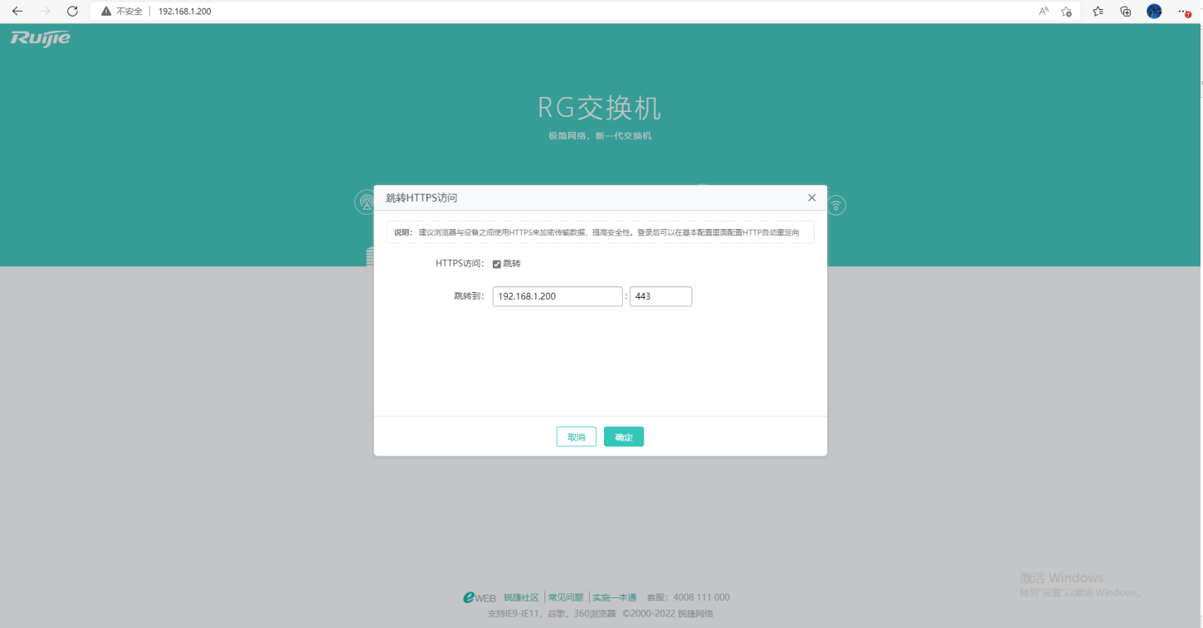

Enter your username and password and then click Log In (登录).
Default Username/Password | Description
admin / admin | Indicates the super administrator with all permissions.
- If the password is not reset, the default account is not saved in the configuration displayed by running the show running-config command.
When logging in to the Web management system with the default username and password, you are required to reset the password for security reasons.
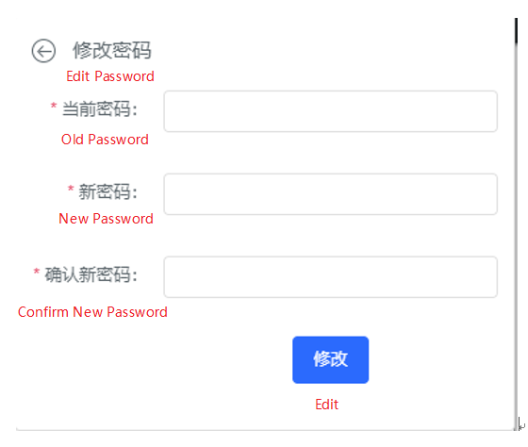
After you log in to the system successfully or reset the password, you will be redirected to the home page of the Web management system.

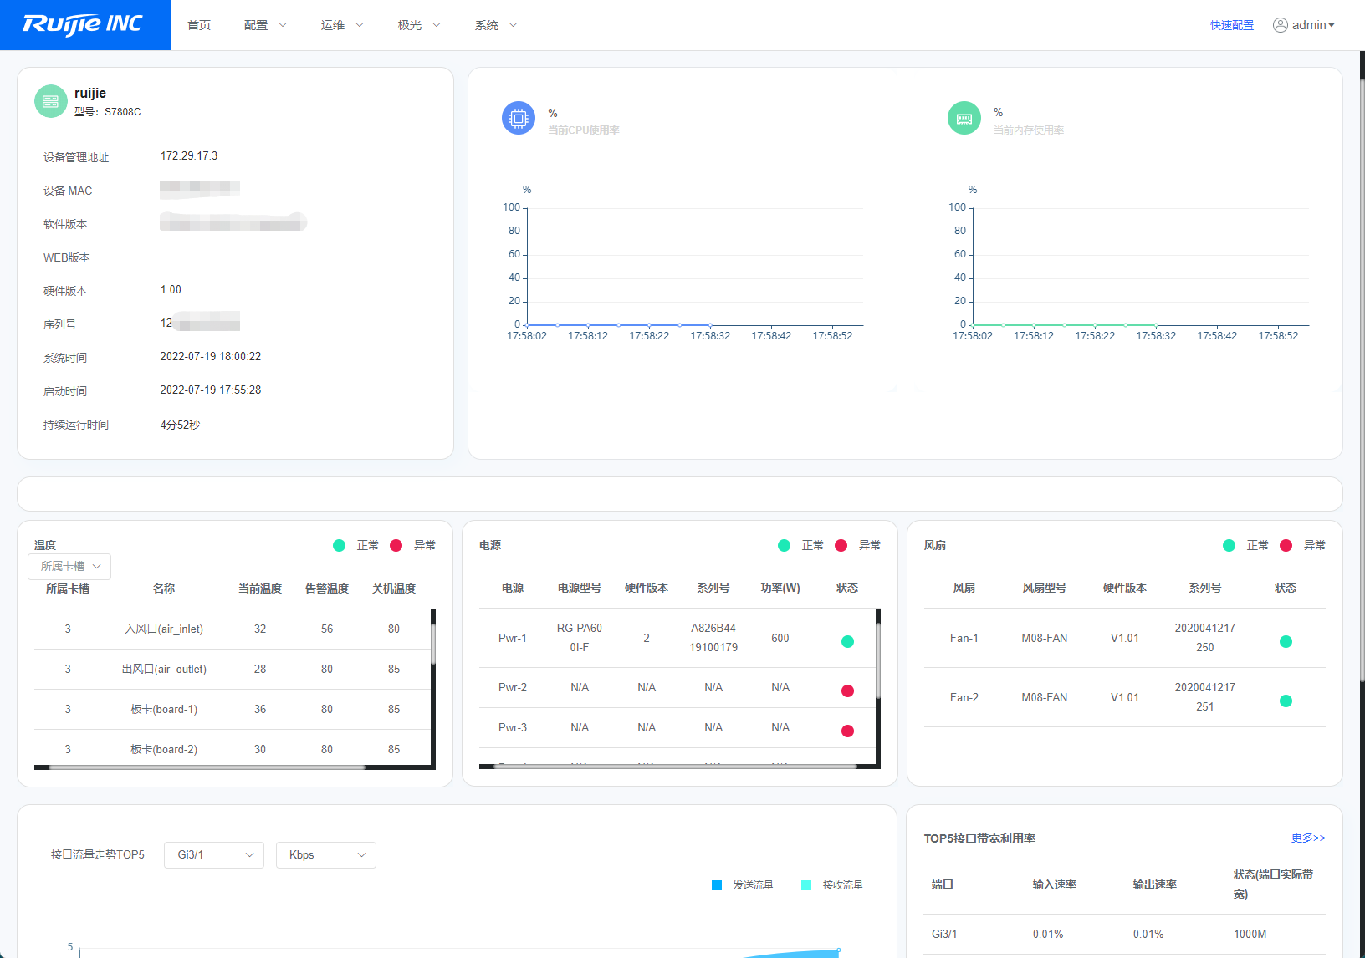

Step 3 Upgrading the Firmware
Click O&M (运维) > Device Upgrade (设备升级) and go to the upgrade page.
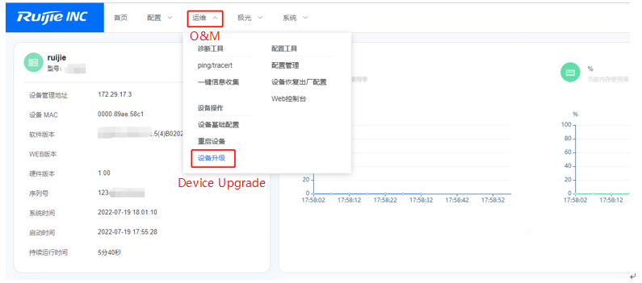
Click Select an upgrade file (点击选择升级包) on the page. Select the local bin file and click Start (开始升级) to upgrade the firmware.
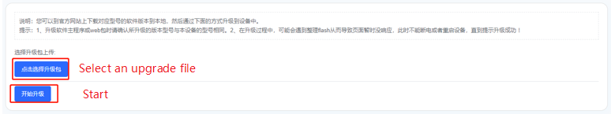
Please wait for about 15 minutes (the upgrade time varies with different models.) until the upgrade is completed and refresh the page. A new page is displayed.

Step 4 Checking the Upgrade Result
If the upgrade is successful, the following login page will be displayed. You can switch the language to English on the page.
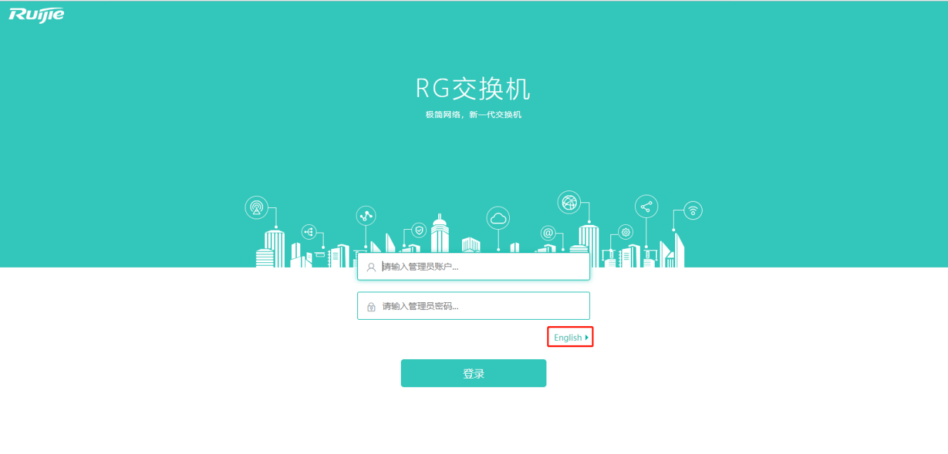

Note: The upgrade takes about 15 minutes.

