- Environment requirement
Ruijie Auto Discovery VPN (ADVPN) allows to dynamically establish direct tunnels (called shortcuts) between the spokes of a traditional Hub and Spoke architecture.
After a shortcut tunnel is established between two spokes and routing has converged, spoke to spoke traffic no longer needs to flow through the Hub. Direct connectivity is provided.
- Topology
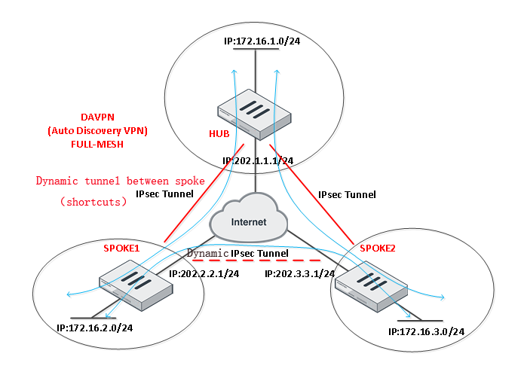

- Configure point
（1）configure HUB
1）the based internet configuration
2）phase1 configuration
3）phase2 configuration
4）configure IPsec VPN tunnel IP
5）configure BGP and Route-Reflector
6）configure policy

(2) configure SPOKE1
1）the based internet configuration
2）phase1 configuration
3）phase2 configuration
4）configure IPsec VPN tunnel IP
5）configure BGP and Route-Reflector
6）configure policy

(3) configure SPOKE2
1）the based internet configuration
2）phase1 configuration
3）phase2 configuration
4）configure IPsec VPN tunnel IP
5）configure BGP and Route-Reflector
6）configure policy

- Configure step
- configure HUB
1)the based internet configuration
wan1: 202.1.1.1/24
internal: 172.16.1.0/24
the detail configuration refer to this guide
https://www.ruijienetworks.com/support/documents/slide_59169
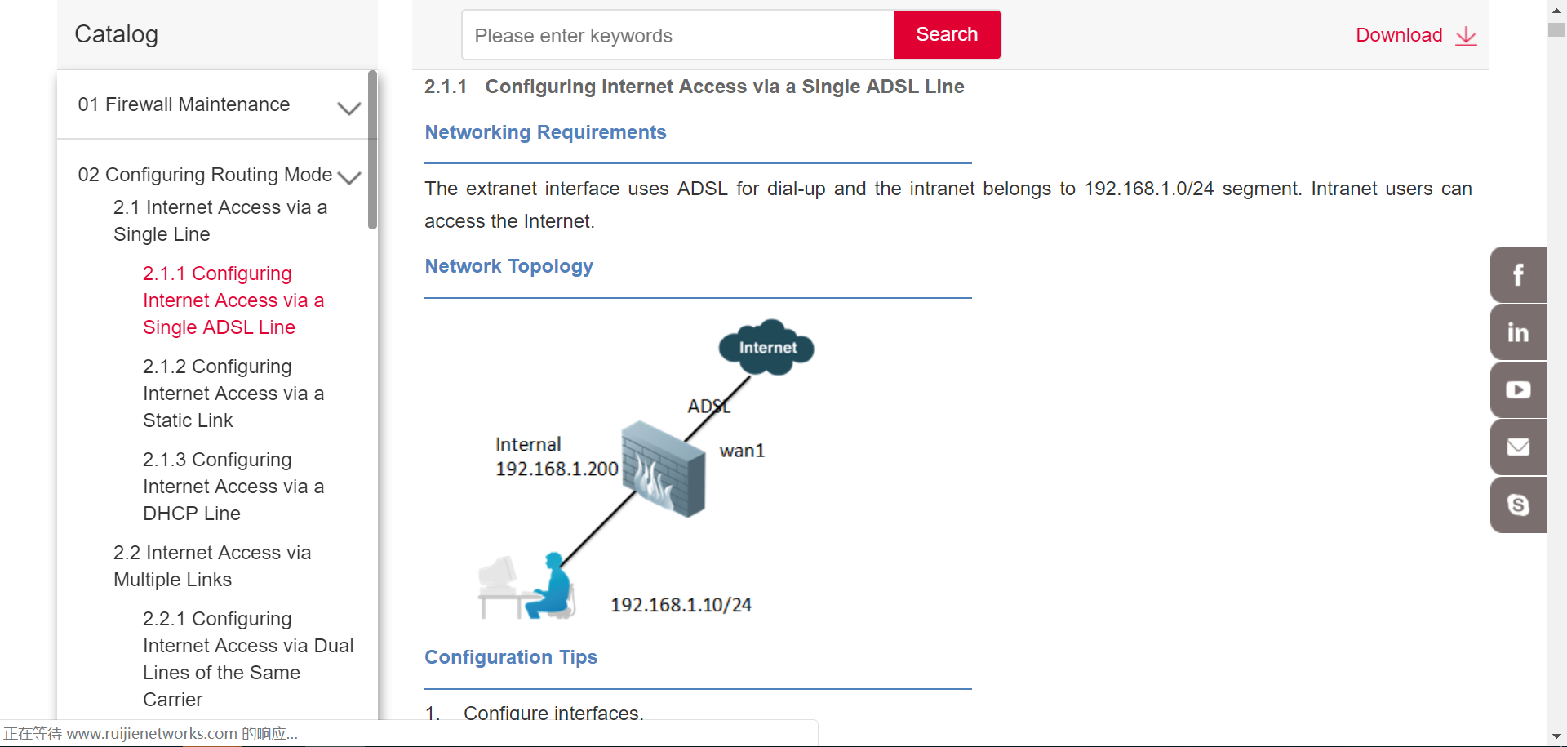
2)configure phase 1(CLI)

Athu way：pre-shared key

config vpn ipsec phase1-interface
edit "ADVPN"
set type dynamic
set interface "wan1"
set psksecret 111111
set add-route disable
set auto-discovery-sender enable
end

- because Hub need to connect with different spoke(static IP /PPPOE) using IPsec VPN, so HUB need to choose dynamic mode

- ADVPN don’t support aggressive mode，only can choose main mode

- HUB need to enable “auto-discovery-sender enable”，so that it can receive and send the data between Spokes.（Hub response information，let Spoke know what public ip tunnel you should connect to）

- Because used BGP，so need to close auto add route function “add-route disable”

3) configure phash2(CLI)

config vpn ipsec phase2-interface
edit "ADVPN"
set phase1name "ADVPN"
next
end

4)configure IPsec VPN tunnel IP

config system interface
edit "ADVPN"
set vdom "root"
set ip 10.10.10.1 255.255.255.255
set allowaccess ping
set type tunnel
set remote-ip 10.10.10.254 （10.10.10.254 isn’t a actual IP）
set interface "wan1"
next
end

5)configure BGP and route-reflector

config router bgp
set as 100
set router-id 10.10.10.1
config neighbor-group // -neighbor-group feature
edit "ADVPN-PEERS"
set remote-as 100
set route-reflector-client enable //-configure route-reflector
next
end
config neighbor-range
edit 1
set prefix 10.10.10.0 255.255.255.0
set neighbor-group "ADVPN-PEERS"
next
end
config network
edit 1
set prefix 172.16.1.0 255.255.255.0 // -release route
next
end

Notice：
1.use BGP neighbor-group feature，BGP-Peer only need to match prefix list 10.10.10.0/24, and then can build BGP neighbor with HUB.
2.configure neighbor to Route-Reflector-Client，itself will be Route-Reflector, and then it can sync total route through route-reflector feature.

6) configure policy

config firewall policy
edit 1
set srcintf "internal"
set dstintf "ADVPN"
set srcaddr "all"
set dstaddr "all"
set action accept
set schedule "always"
set service "ALL"
set status enable
next
edit 2
set srcintf "ADVPN"
set dstintf "internal"
set srcaddr "all"
set dstaddr "all"
set action accept
set schedule "always"
set service "ALL"
set status enable
next
edit 3
set srcintf "ADVPN"
set dstintf "ADVPN"
set srcaddr "all"
set dstaddr "all"
set action accept
set schedule "always"
set service "ALL"
set status enable
next
end
- configure SPOKE1

1)based network configuration
1. The same with Hub
2. Interface IP configure：
wan1: 202.2.2.1/24
internal: 172.16.2.0/24

2)configure phase1(CLI)

config vpn ipsec phase1-interface
edit "ADVPN"
set interface "wan1"
set remote-gw 202.1.1.1
set psksecret 111111
set add-route disable
set auto-discovery-receiver enable
next
end

Notice：

a. because HUB public IP is static，so Spoke need to configure static IPsec VPN
b. Spoke need to enable “auto-discovery-receiver enable”，so that it can receive the ADVPN data of Hub.
c. because Spoke need to use BGP，so need to disable add-route function（add-route disable）

3) configure phase 2(CLI)

config vpn ipsec phase2-interface
edit "ADVPN"
set phase1name "ADVPN"
set auto-negotiate enable
next

4) configure IPsec VPN tunnel IP

config system interface
edit "ADVPN"
set vdom "root"
set ip 10.10.10.2 255.255.255.255
set allowaccess ping
set type tunnel
set remote-ip 10.10.10.1 // the tunnel IP point to Hub
set interface "wan1"
next
end

5)configure BGP and route-rejector

config router bgp
set as 100
set router-id 10.10.10.2
config neighbor
edit "10.10.10.1" \\ only need to build BGP neighbor with Hub
set remote-as 100
next
end
config network
edit 1
set prefix 172.16.2.0 255.255.255.0
next
end

configure static route to let IBGP up

config router static
edit 2
set dst 10.10.10.0 255.255.255.0
set device "ADVPN"
next
end

Notice：

All Spoke need to configure 10.10.10.0/24 next-hop point to ADVPN，the route of BGP is based on IGP，So need to make sure IGP route can be up，or will have route hole。（because SPOKE1 learned the BGP route 172.16.3.0/24 of SPOKE2 next-hop is point to 10.10.10.3，but SPOKE1 go to 10.10.10.3 using static route，will be forward to ISP device，the forwarding business data between SPOKE will be wrong，at the same time can’t touch off ADVPN，So need to add a static route to 10.10.10.0/24 point to ADVPN tunnel.

6) configure policy

config firewall policy
edit 0
set srcintf "internal"
set dstintf "ADVPN"
set srcaddr "all"
set dstaddr "all"
set action accept
set schedule "always"
set service "ALL"
set status enable
next
edit 0
set srcintf "ADVPN"
set dstintf "internal"
set srcaddr "all"
set dstaddr "all"
set action accept
set schedule "always"
set service "ALL"
set status enable
next
end

- configure SPOKE2

1)based network configuration
The same with Hub
Interface configure
wan1: 202.3.3.1/24
internal: 172.16.3.0/24

2)configure phase 1(CLI)

config vpn ipsec phase1-interface
edit "ADVPN"
set interface "wan1"
set remote-gw 202.1.1.1
set psksecret 111111
set add-route disable
set auto-discovery-receiver enable
next
end

3)configure phase 2(CLI)

config vpn ipsec phase2-interface
edit "ADVPN"
set phase1name "ADVPN"
set auto-negotiate enable
next

4)configure IPsec VPN tunnel IP

config system interface
edit "ADVPN"
set vdom "root"
set ip 10.10.10.3 255.255.255.255
set allowaccess ping
set type tunnel
set remote-ip 10.10.10.1 // the tunnel IP point to HUB
set interface "wan1"
next
end

5)configure BGP and route-rejector

config router bgp
set as 100
set router-id 10.10.10.3
config neighbor
edit "10.10.10.1"
set remote-as 100
next
end
config network
edit 1
set prefix 172.16.3.0 255.255.255.0
next
end

configure static route to let IBGP be up打通IBGP

config router static
edit 0
set dst 10.10.10.0 255.255.255.0
set device "ADVPN"
next
end

6) configure policy

config firewall policy
edit 0
set srcintf lan
set dstintf "ADVPN"
set srcaddr "all"
set dstaddr "all"
set action accept
set schedule "always"
set service "ALL"
set status enablb
next
edit 0
set srcintf "ADVPN"
set dstintf lan
set srcaddr "all"
set dstaddr "all"
set action accept
set schedule "always"
set service "ALL"
set status enable
next
end

- check configuration result

VPN->Monitor->Ipsec monitor
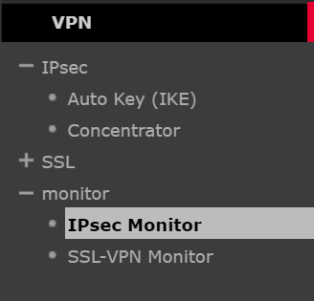
Route -> Monitor-> routing Monitor


